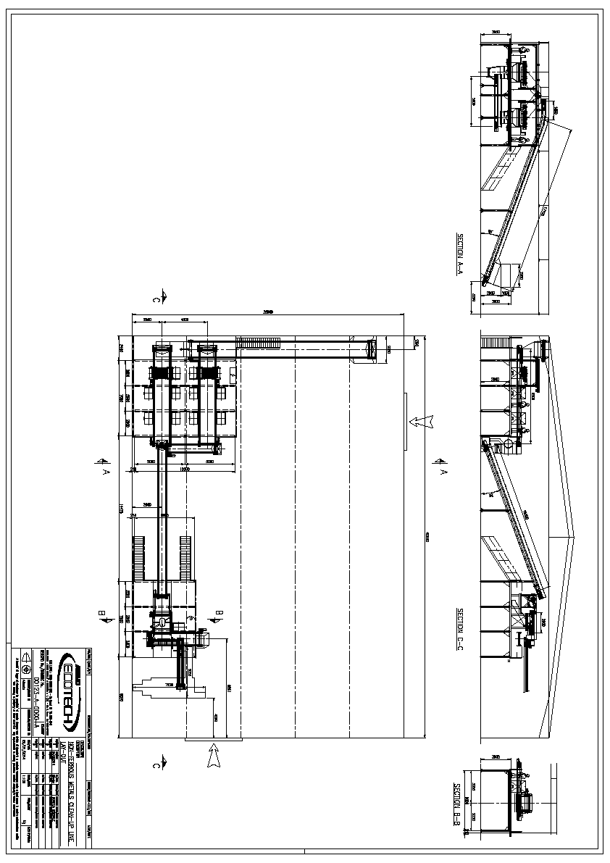
Can Sorting Line & Baler Specification

Can Sort Line
NON-FERROUS METAL CLEAN–UP LINE
ITEM N° DESCRIPTION OF COMPONENTS
06 FEEDING LINE CONVEYOR BELT
Type TNS 1,60x19,00
Incline feeding conveyor
Width mm 1.600
Length mm 19.000
Installed electrical power kW 5,50
Slope (α) deg 18
07 FLOW DIVIDER
Fitted at the head of the feeding conveyor at the pos. 07, consisting
of a drum and an infeed chamber
08 CONVEYOR BELT
Type TNS 1,60x9,30
Picking belt conveyor
Width mm 1.600
Length mm 9.300
Installed electrical power kW 4,00/each
Slope (α) deg 0
09 MAGNETIC SEPARATOR BELT
Type SMB92-120E
Over band Magnetic Separator fitted on the picking conveyors Pos.
08
Installed electrical power kW 3,00/each
10 MAGNETIC DRUMS
Type TM
Fitted at the head of the picking conveyor belts
11 SELECTION SORTING PLATFORM
Type TA 10,00x9,00
Picking platform
Width mm 10.000
Length mm 9.000
12 CONVEYOR BELT
Type TNS 0,80x4,50
Incline feeding ECS conveyor belt receiving from picking conveyors
Width mm 800
Length mm 4.500
Installed electrical power kW 2,20/each
Slop
13 VIBRATING FEEDER Type EVA 140/17,5
Vibrating feeder
Useful length mm 1.750
Used width mm 1.400
14 NON FERROUS SEPARATOR
Type ECS 1500
Eddy current separator
Installed electrical power kW 6,60
15 CONVEYOR BELT
Type TNS 1,60x3,00
Picking belt conveyor
Width mm 1.600
Length mm 3.000
Installed electrical power kW 3,00
Slope (α) deg 0
16 SELECTION SORTING PLATFORM
Type TA 5,50x9,00
Picking platform
Width mm 5.500
Length mm 9.000e (α) deg 25

Baler
MOROS GC-J-125 AUTOMATICSCRAP BALING PRESS
BALE SIZE 400 X 400 MM. ( 16" X 16" )
PROPOSAL SPECIFICATION :
APPLICATION : Steel off-cuts, Industrial clips and skeletons,
Loose sheet, Trim stock, Wire and
miscellaneous shapes.
A CAPACITY AND RATING:
1 Pre-compression Box dimensions : Length ......................... 2.100 mm. ...... ( 83" )
Width ........................... 1.250 mm. ...... ( 49" )
Depth ............................. 760 mm. ...... ( 30" )
2 Charging Box Opening :
When 2nd compression Lid open : 2.500 x 1.250 mm. ..................... ( 98" x 49" )
When 2nd compression Lid closed : 2.100 x 1.250 mm. ..................... ( 83" x 49" )
3 Second Compression Box Dimensions : Length ......................... 1.300 mm. ...... ( 51" )
Width .............................. 400 mm. ...... ( 16" )
Depth .......................... 1.650 mm. ...... ( 65" )
4 Final Compression Box Dimensions : Length ......................... 1.900 mm. ...... ( 75" )
Width .............................. 400 mm. ...... ( 16" )
Depth ............................. 400 mm. ...... ( 16" )
5 Bale Size : 400 x 400 x 300 / 600 mm.
(depending on loading ) ( 16" x 16" x 12" / 24" )
6 Bale Weight : 90 - 180 kg. ........................ for ferrous scrap
( depending on bale length ) ( 200 - 400 pounds )
35 - 70 kg. ..................... for aluminium scrap
( 77 - 154 pounds )
7 Average Bale Weight and Size : 120 kg. .....................( 400 x 400 x 400 mm.)
280 pounds ........................ ( 16" x 16" x 16")
8 Average Baling Cycle Time :
( One precom. stroke only ) ...................................................................................... 36 - 37 seconds
9 Average Bales Production :
( When loading is carried out during the final
compression and the return of all rams ) ............................................................ 90 / 100 bales / hour
10 Average hourly Production :
( When loading is carried out during the final
compression and the return of all rams ) ...................................... 8 - 12 tons / hour for ferrous scrap
Industrias Hidráulicas, s.a. GC-J-125
GC-J-125-uk 28-02-13 Page 2
.

